#day 1 pro 1
# Load necessary library
library(ggplot2)
# Create a data frame
weight_height_data <- data.frame(
Weight = c(60, 65, 70, 72, 75),
Height = c(170, 175, 168, 180, 178)
)
# Plot scatter plot
ggplot(weight_height_data, aes(x = Weight, y = Height)) +
geom_point(color = "blue", size = 3) +
labs(title = "Weight vs. Height",
x = "Weight (kg)",
y = "Height (cm)") +
theme_minimal()
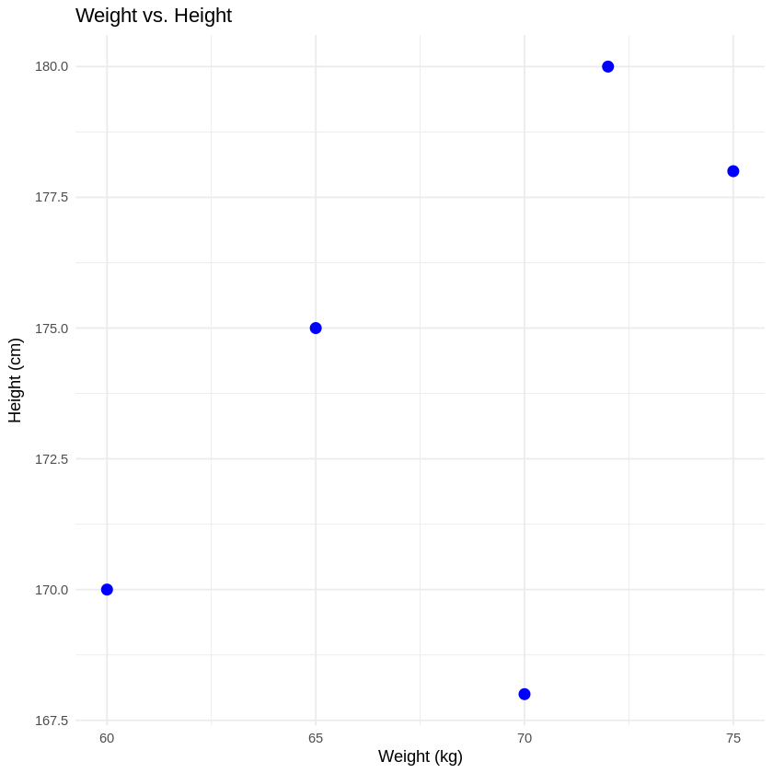
# day 1 pro 2
# Create a data frame
year_population_data <- data.frame(
Year = 2010:2014,
Population = c(1000, 1020, 1040, 1060, 1080)
)
# Plot line plot
ggplot(year_population_data, aes(x = Year, y = Population)) +
geom_line(color = "green", size = 1) +
geom_point(color ="red", size = 3) +
labs(title = "Year vs. Population",
x = "Year",
y = "Population(millions)") +
theme_minimal()
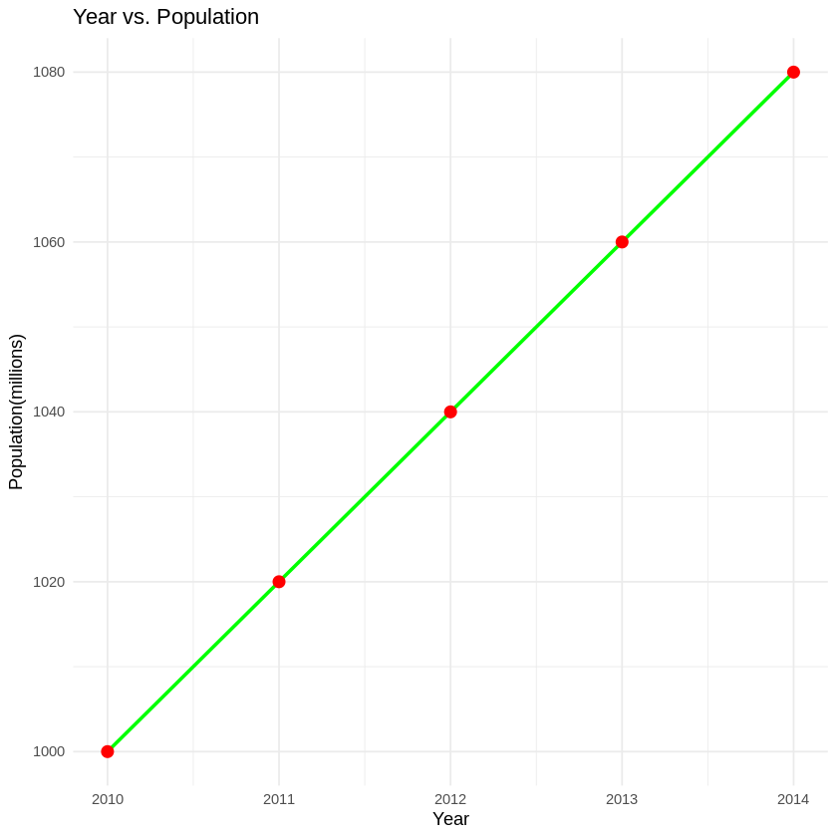
# day 1 pro 3
# Create a data frame
sales_data <- data.frame(
Product = c("A", "B", "C", "D", "E"),
Sales = c(300, 450, 500, 350, 400)
)

# Plot bar plot
ggplot(sales_data, aes(x = Product, y = Sales, fill = Product)) +
geom_bar(stat = "identity") +
labs(
title = "Sales by Product",
x = "Product",
y = "Sales"
) +
theme_minimal()

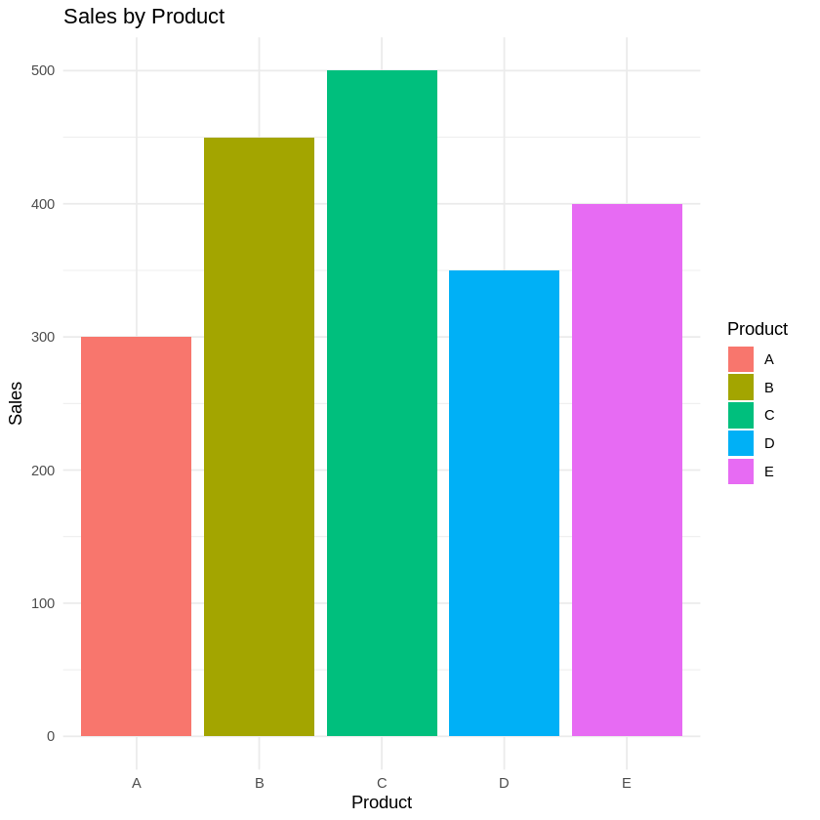
#day 1 pro 4
library(ggplot2)

# Create a data frame
age_data <- data.frame(
Age = c(25, 30, 35, 40, 45, 50, 55, 60, 65, 70)
)

# Plot histogram
ggplot(age_data, aes(x = Age)) +
geom_histogram(
binwidth = 5,
fill = "purple",
color = "black",
alpha = 0.7
) +
labs(
title = "Age Distribution",
x = "Age",
y = "Frequency"
) +
theme_minimal()

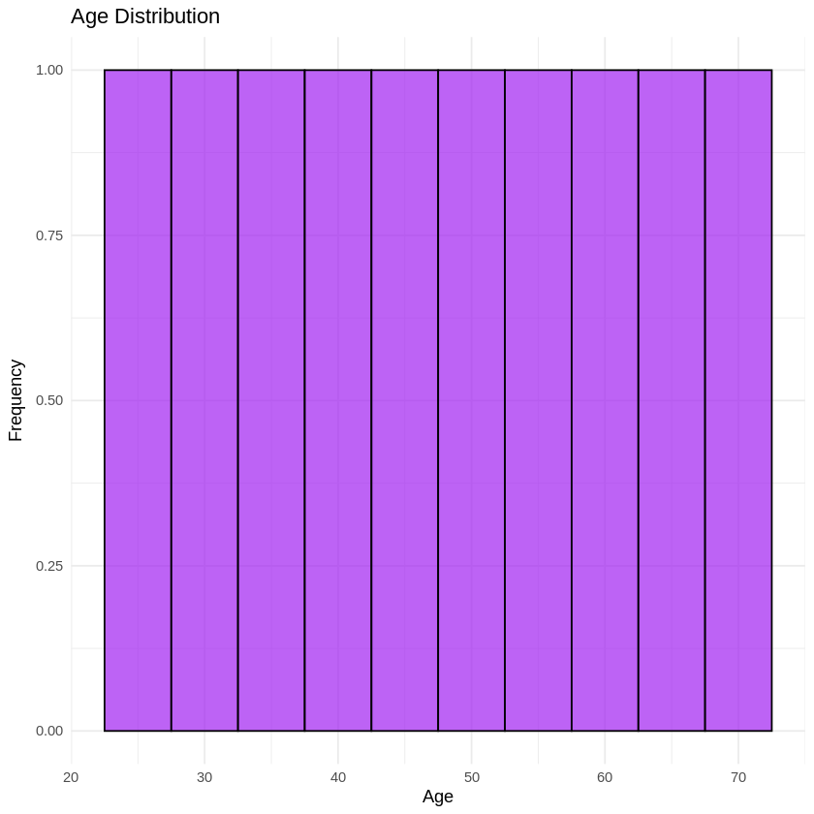
#day 1 pro 5
library(ggplot2)

# Create a data frame
market_share_data <- data.frame(
Company = c("A", "B", "C", "D"),
Market_Share = c(20, 30, 25, 25)
)

# Plot pie chart
ggplot(market_share_data, aes(x = "", y = Market_Share, fill = Company)) +
geom_bar(stat = "identity", width = 1) +
coord_polar("y") +
labs(
title = "Market Share by Company",
x = NULL,
y = NULL
) +
theme_void() +
theme(legend.position = "right")
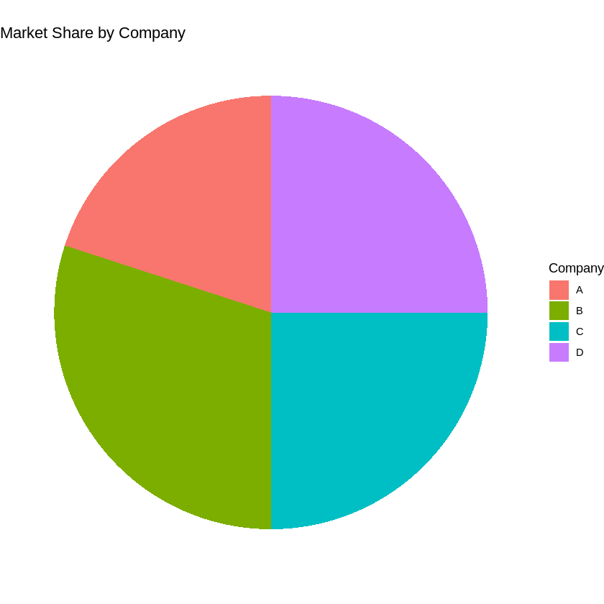
# day 1 pro 6
library(ggplot2)

# Create a data frame
scores_data <- data.frame(
Class = c("A", "A", "A", "A", "B", "B", "B", "B"),
Scores = c(85, 90, 78, 92, 88, 76, 80, 84)
)

# Plot box plot
ggplot(scores_data, aes(x = Class, y = Scores, fill = Class)) +
geom_boxplot() +
labs(
title = "Exam Scores by Class",
x = "Class",
y = "Scores"
) +
theme_minimal()

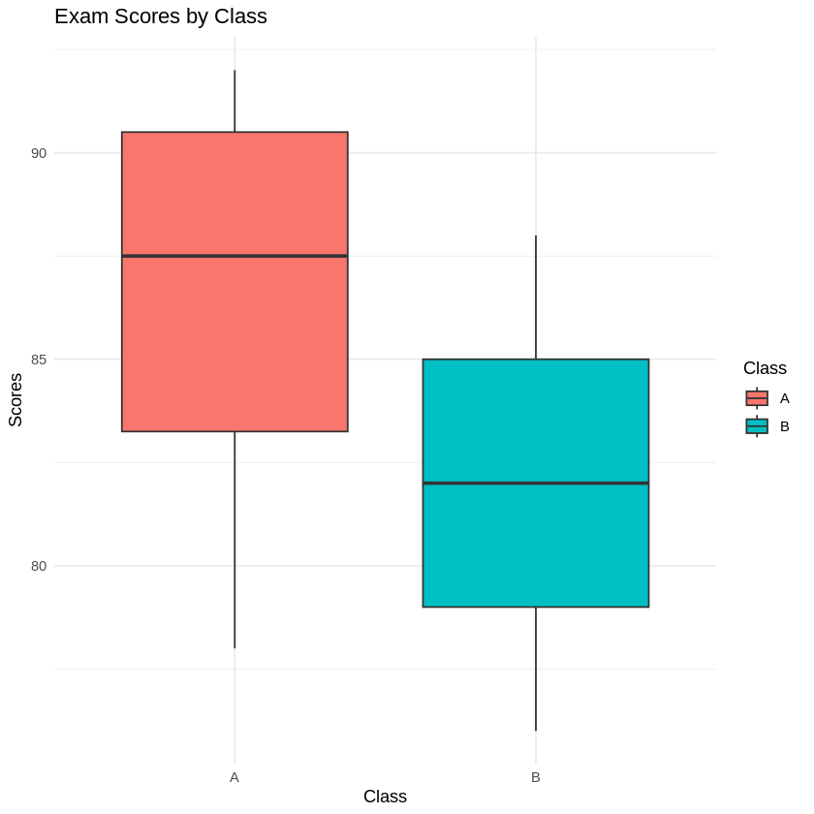
#day 1 pro 7
library(ggplot2)

# Create a data frame
weights_data <- data.frame(
Weight = c(60, 65, 70, 75, 80, 85, 90, 95, 100)
)

# Plot density plot
ggplot(weights_data, aes(x = Weight)) +
geom_density(fill = "lightblue") +
labs(
title = "Density Plot of Weights",
x = "Weight (kg)",
y = "Density"
) +
theme_minimal()

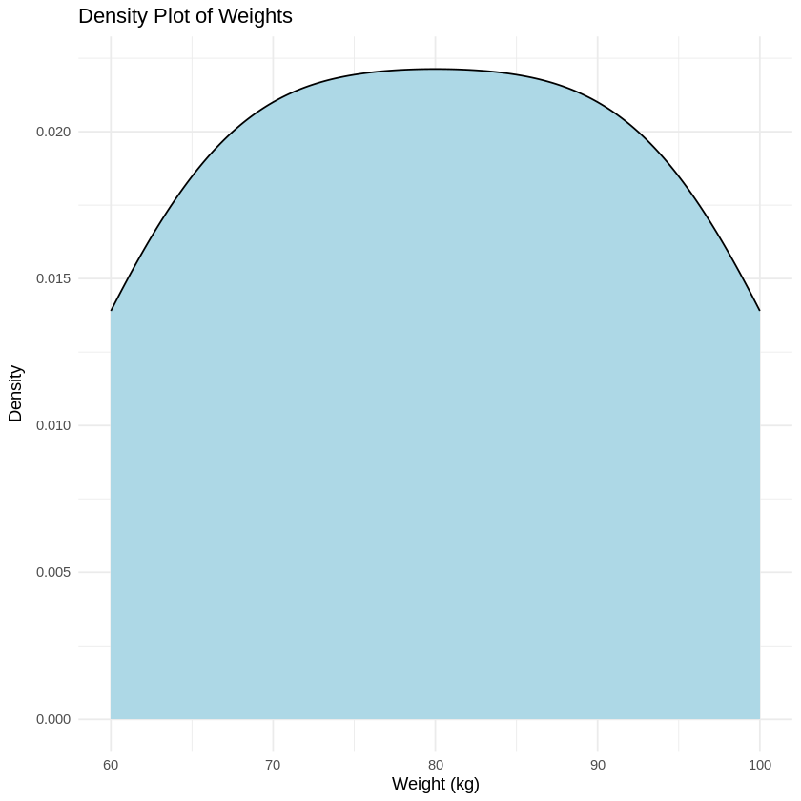
#day 1 pro 8
library(ggplot2)

# Create a data frame
scores_group_data <- data.frame(
Group = c("X", "X", "X", "X", "Y", "Y", "Y", "Y"),
Score = c(80, 85, 78, 92, 88, 76, 80, 84)
)

# Plot violin plot
ggplot(scores_group_data, aes(x = Group, y = Score, fill = Group)) +
geom_violin() +
labs(
title = "Scores by Group",
x = "Group",
y = "Score"
) +
theme_minimal()

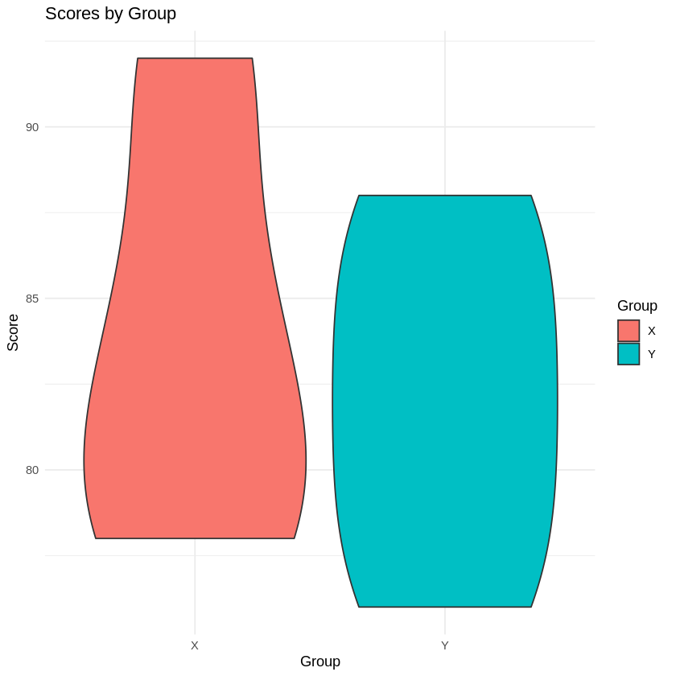
#day 1 pro 9
# Load required libraries
library(ggplot2)
library(tidyr) # part of tidyverse

# Create data frame
temperature_data <- data.frame(
Month = c("Jan", "Feb", "Mar", "Apr", "May"),
City_A = c(5, 6, 7, 8, 9),
City_B = c(10, 11, 12, 13, 14),
City_C = c(15, 16, 17, 18, 19)
)

# Reshape data using pivot_longer
melted_data <- pivot_longer(
temperature_data,
cols = -Month,
names_to = "City",
values_to = "Temperature"
)
# Plot heatmap
ggplot(melted_data, aes(x = Month, y = City, fill = Temperature)) +
geom_tile() +
scale_fill_gradient(low = "white", high = "black") +
labs(
title = "Monthly Temperatures",
x = "Month",
y = "City"
) +
theme_minimal()
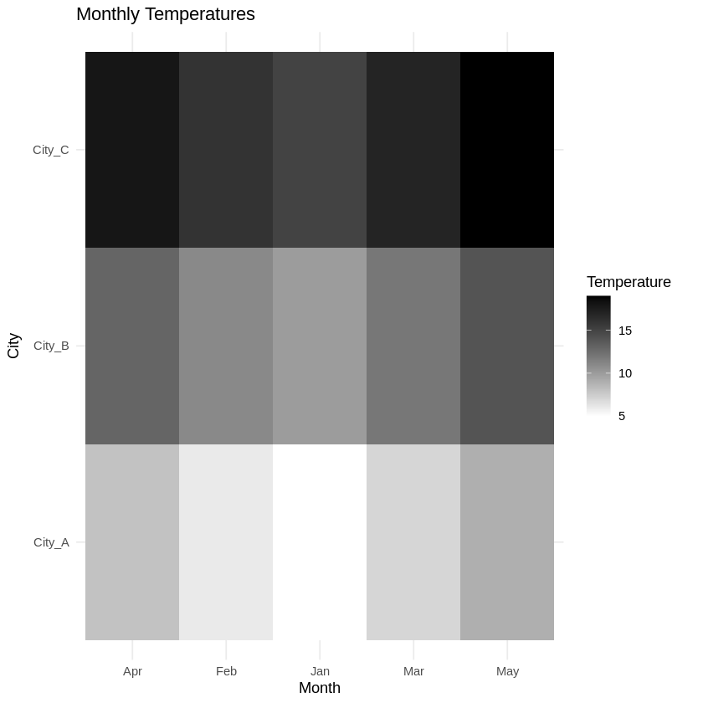
#day 1 pro 10
library(ggplot2)

# Create a data frame
sales_region_data <- data.frame(
Month = c("Jan", "Jan", "Feb", "Feb", "Mar", "Mar"),
Region = c("East", "West", "East", "West", "East", "West"),
Sales = c(200, 150, 220, 170, 210, 160)
)

# Plot facet plot
ggplot(sales_region_data, aes(x = Month, y = Sales, fill = Region)) +
geom_bar(stat = "identity", position = "dodge") +
facet_wrap(~ Region) +
labs(
title = "Sales by Month and Region",
x = "Month",
y = "Sales"
) +
theme_minimal()

# day 2 pro 11
# Create a data frame
revenue_data <- data.frame(
Year = 2015:2019,
Revenue = c(30, 35, 40, 45, 50)
)
# Plot area plot
ggplot(revenue_data, aes(x = Year, y = Revenue)) +
geom_area(fill = "skyblue", alpha = 0.5) +
labs(title = "Yearly Revenue",
x = "Year",
y = "Revenue (in million)") +
theme_minimal()
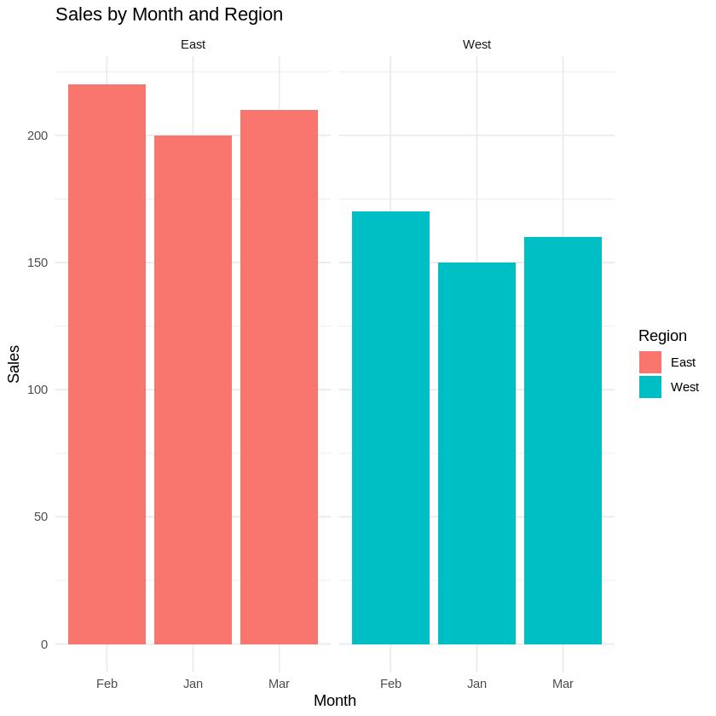
# day 2 pro 11
# Create a data frame
revenue_data <- data.frame(
Year = 2015:2019,
Revenue = c(30, 35, 40, 45, 50)
)
# Plot area plot
ggplot(revenue_data, aes(x = Year, y = Revenue)) +
geom_area(fill = "skyblue", alpha = 0.5) +
labs(title = "Yearly Revenue",
x = "Year",
y = "Revenue (in million)") +
theme_minimal()
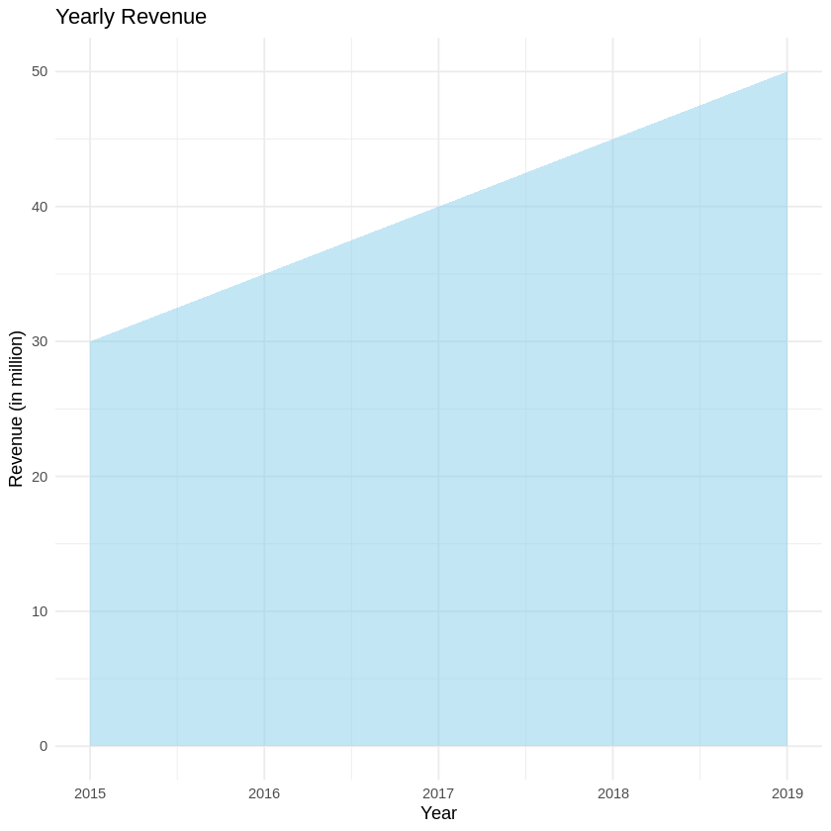
#day 2 pro 12
# Load necessary library
library(ggplot2)
# Create a data frame
cumulative_sales_data <- data.frame(
Month = factor(c("Jan", "Feb", "Mar", "Apr", "May"), levels = c("Jan", "Feb", "Mar",
"Apr", "May")),
Cumulative_Sales = c(100, 200, 300, 400, 500)
)
# Create the step plot
ggplot(cumulative_sales_data, aes(x = Month, y = Cumulative_Sales, group = 1)) +
geom_step() +
labs(title = "Cumulative Sales Over Months",
x = "Month",
y = "Cumulative Sales") +
theme_minimal()
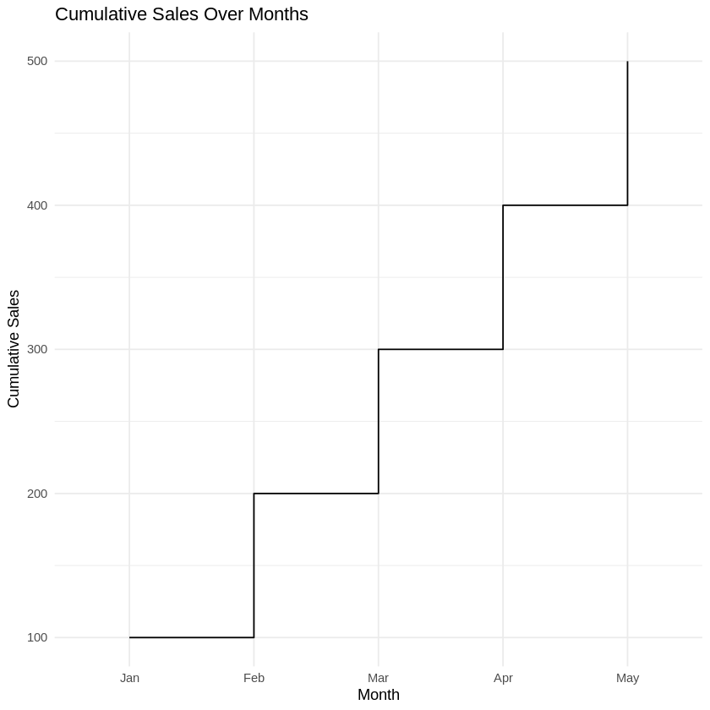
#day 2 pro 13
library(ggplot2)
library(ggridges)

# Create a data frame
temperature_data <- data.frame(
City = c("City1", "City1", "City1", "City2", "City2", "City2"),
Temperature = c(20, 21, 19, 22, 23, 24)
)

# Plot ridgeline plot
ggplot(temperature_data, aes(x = Temperature, y = City, fill = City)) +
geom_density_ridges(alpha = 0.7) +
labs(
title = "Temperature Distributions",
x = "Temperature",
y = "City"
) +
theme_minimal()

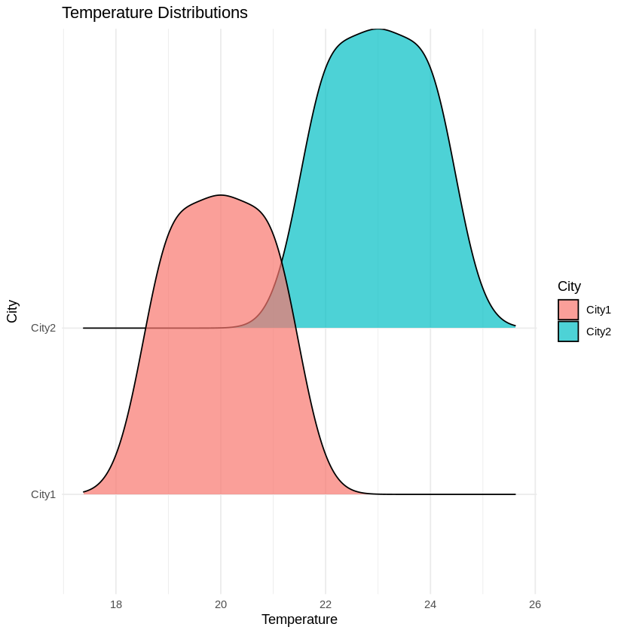
#day 2 pro 14
library(ggplot2)

# Create a data frame
sales_campaign_data <- data.frame(
Product = c("A", "B", "C"),
Before = c(200, 300, 400),
After = c(250, 350, 450)
)

# Convert to long format for plotting points
library(tidyr)
long_data <- pivot_longer(sales_campaign_data, cols = c(Before, After),
names_to = "Time", values_to = "Sales")

# Plot dumbbell-like plot
ggplot(long_data, aes(x = Sales, y = Product, color = Time)) +
geom_line(aes(group = Product), color = "gray", size = 2) + # line connecting before/after
geom_point(size = 4) +
labs(
title = "Sales Before and After Campaign",
x = "Sales",
y = "Product"
) +
theme_minimal() +
scale_color_manual(values = c("Before" = "blue", "After" = "red"))

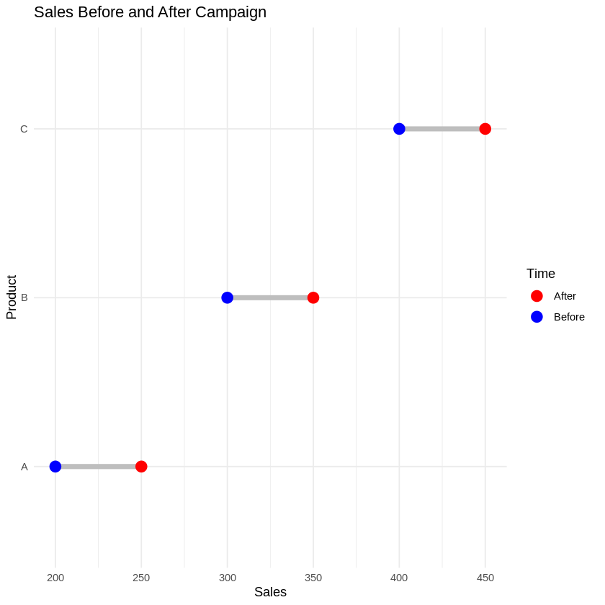
#day 2 pro 15
# Load ggplot2
library(ggplot2)

# Create a data frame
sales_region_data <- data.frame(
Region = c("North", "South", "East", "West"),
Sales = c(150, 200, 180, 210)
)

# Plot lollipop plot
ggplot(sales_region_data, aes(x = Region, y = Sales)) +
geom_segment(aes(x = Region, xend = Region, y = 0, yend = Sales), color = "gray") +
geom_point(color = "blue", size = 5) +
labs(
title = "Sales by Region",
x = "Region",
y = "Sales"
) +
theme_minimal()
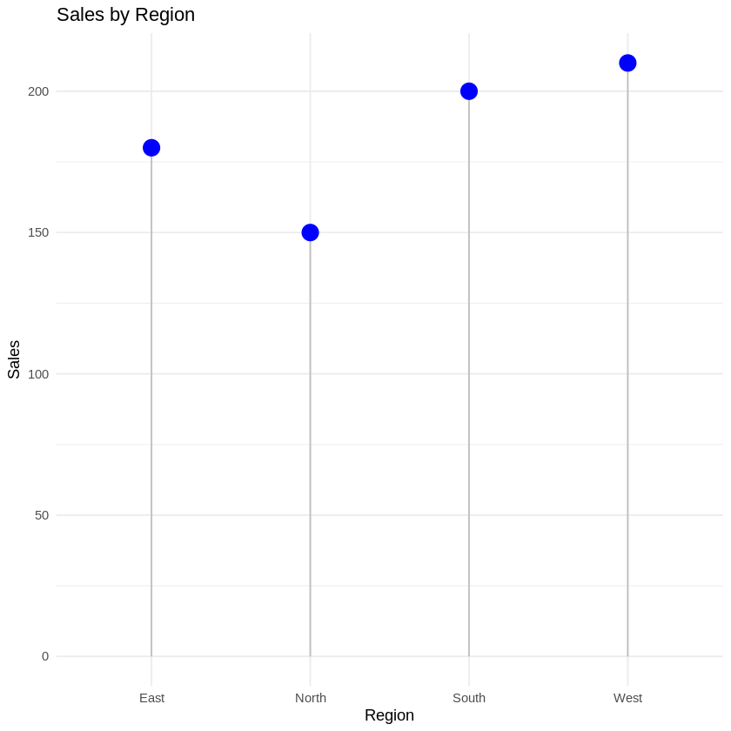
#day2 pro 16
# Load ggplot2
library(ggplot2)

# Create a data frame
sales_time_data <- data.frame(
Month = c("Jan", "Feb", "Mar", "Jan", "Feb", "Mar"),
Product = c("A", "A", "A", "B", "B", "B"),
Sales = c(100, 150, 130, 120, 140, 160)
)

# Plot spaghetti plot
ggplot(sales_time_data, aes(x = Month, y = Sales, group = Product, color = Product)) +
geom_line(size = 1) +
geom_point(size = 3) +
labs(
title = "Sales over Time by Product",
x = "Month",
y = "Sales"
) +
theme_minimal()

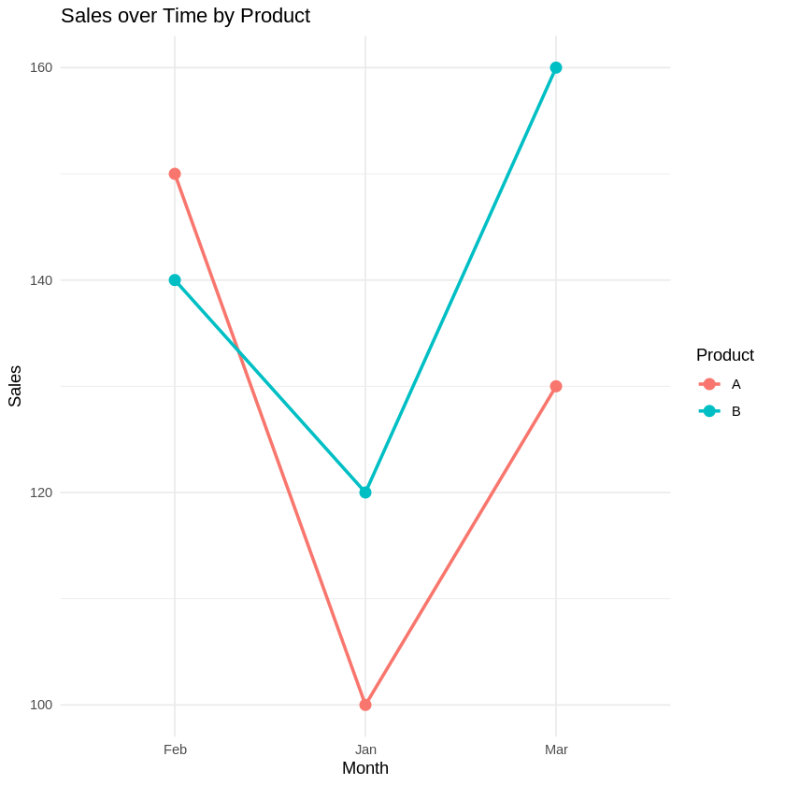
#day2 pro 17
# Install waterfalls if not installed
# install.packages("waterfalls")

# Load necessary library
library(waterfalls)

# Create a data frame
profit_loss_data <- data.frame(
labels = c("Jan", "Feb", "Mar", "Apr", "May"),
values = c(100, -20, 50, -10, 80)
)

# Plot waterfall plot
waterfall(profit_loss_data, fill_by_sign = TRUE)

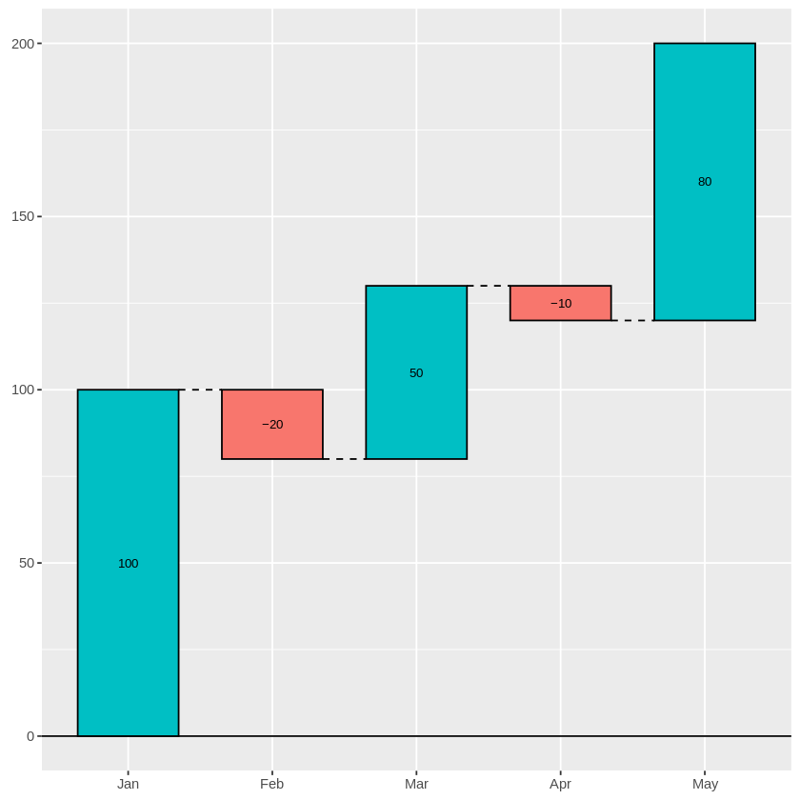
#day2 pro 18
# Load necessary libraries
library(ggplot2)
library(hexbin)

# Create a data frame
xy_data <- data.frame(
X = c(1, 2, 3, 4, 5, 6, 7, 8),
Y = c(2, 3, 4, 5, 6, 7, 8, 9)
)

# Plot hexbin plot
ggplot(xy_data, aes(x = X, y = Y)) +
geom_hex() +
labs(
title = "Hexbin Plot",
x = "X",
y = "Y"
) +
theme_minimal()

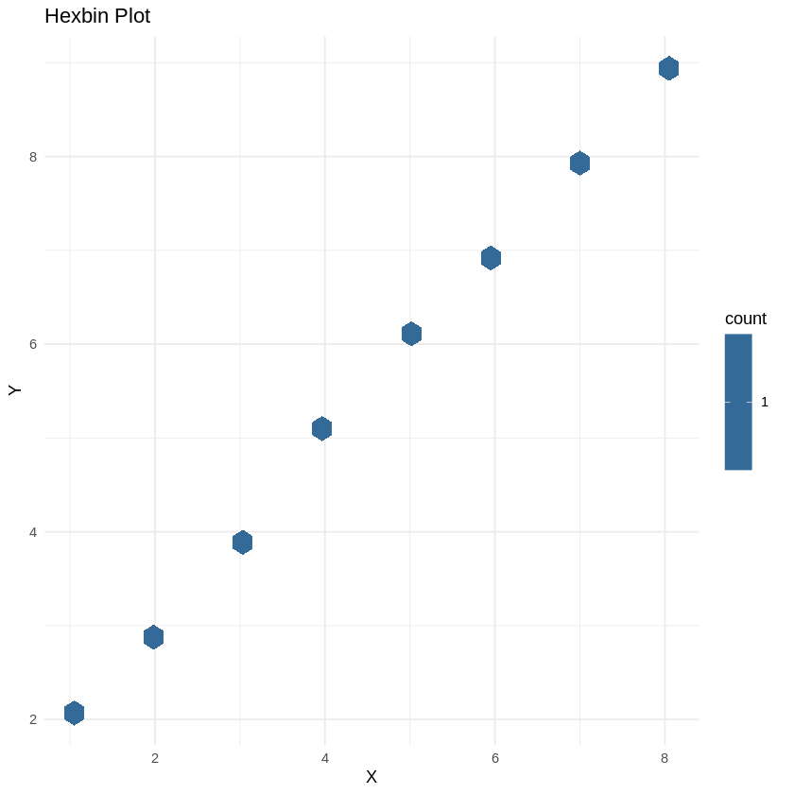
#day2 pro 19
# Load necessary library
library(circlize)

# Create a data frame
chord_data <- data.frame(
From = c("A", "A", "B", "B", "C"),
To = c("B", "C", "C", "D", "D"),
Value = c(10, 20, 15, 25, 30)
)

# Plot chord diagram
chordDiagram(chord_data)

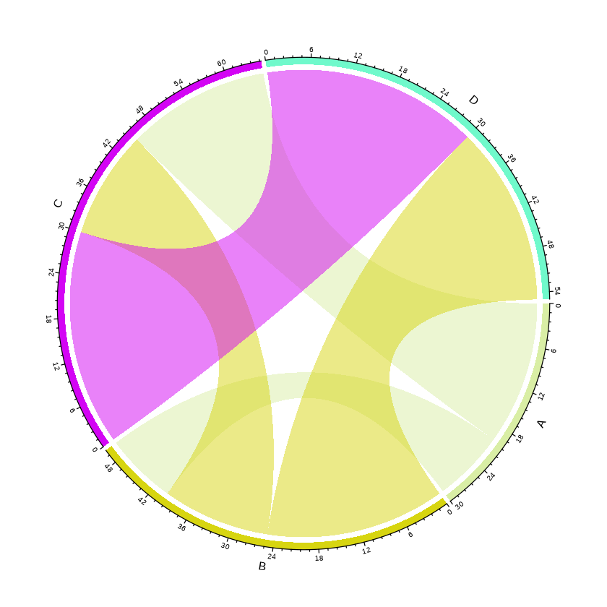
#day2 pro 20
# Load library
library(ggplot2)

# Sample data
data <- data.frame(
Date = as.Date(c("2023-01-01","2023-01-02","2023-01-03","2023-01-04","2023-01-05")),
Count = c(10, 12, 15, 8, 20)
)

# Add weekday and week number
data$Weekday <- weekdays(data$Date)
data$Week <- as.numeric(format(data$Date, "%U")) + 1 # Week of year

# Plot simple calendar heatmap
ggplot(data, aes(x = Weekday, y = -Week, fill = Count)) +
geom_tile(color = "white") +
scale_fill_gradient(low = "white", high = "steelblue") +
labs(title = "Daily Activity Heatmap", x = "Weekday", y = "Week") +
theme_minimal()

